8. PROJECT DEMONSTRATION PHASE:
8.1 Demonstration Overview:
The Project Demonstration Phase presents the working features of the Salesforce-based Courier Management System. The demonstration explains how users can manage customers, shipments, delivery agents, branches, delivery updates, invoices, reports, and dashboards through the Salesforce application.
The demonstration also shows the automation and security features implemented in the system. Each major function is demonstrated using the configured Salesforce records and application screens.
8.2 Demonstration Flow:
The system demonstration follows this sequence:
Login → Home Dashboard → Customer Management → Shipment Creation → Agent Assignment → Delivery Update → Flow Automation → Invoice Management → Reports → Dashboard
8.3 Demonstration Activities:
S.No. | Demonstration Activity | Description
1 | Salesforce Login | Login to the Salesforce application using authorized credentials.
2 | Home Dashboard | Display the Courier Management System home page and dashboard.
3 | Customer Management | Create and manage customer records.
4 | Shipment Management | Create shipment records with tracking and delivery details.
5 | Agent Assignment | Assign available delivery agents to shipments.
6 | Delivery Update | Update shipment status such as In Transit, Delivered, Pending, or Delayed.
7 | Flow Automation | Demonstrate automatic shipment-status updates using Salesforce Flow.
8 | Invoice Management | Create and manage invoice and payment information.
9 | Reports | Display shipment, agent-performance, and revenue reports.
10 | Dashboard | Demonstrate charts and summary information for courier operations.
8.4 Key Features Demonstrated:
Feature | Demonstration Result
Customer Management | Customer records can be created and maintained.
Shipment Tracking | Shipment details and tracking numbers can be managed.
Agent Management | Delivery agents can be assigned to shipments.
Delivery Updates | Shipment status can be updated and monitored.
Flow Automation | Shipment status is automatically synchronized.
Invoice Management | Billing and payment information can be maintained.
Security | User access is controlled using profiles and roles.
Reports | Courier information can be analyzed using reports.
Dashboard | Operational information is displayed using charts and summary components.

8.6 Demonstration Outcome:
The project demonstration successfully presents the major features and workflows of the Courier Management System. The demonstration shows how Salesforce can be used to manage courier information, automate shipment-status updates, control user access, generate reports, and monitor operations through dashboards.
The demonstration provides practical evidence that the implemented system supports the defined project requirements and can be used as a centralized platform for courier management.
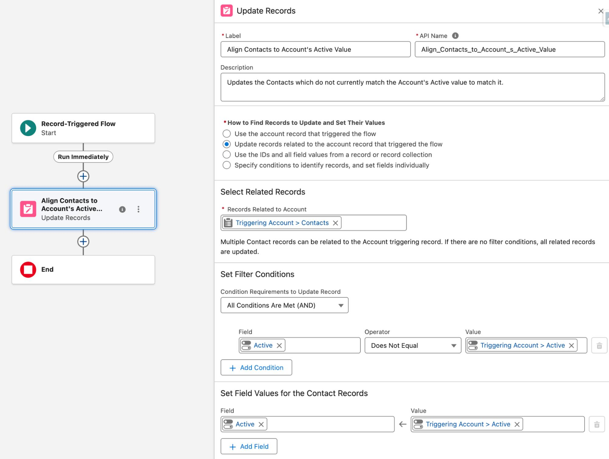

- FINAL OUTCOME:

